Continental Drift: Theory & Definition
By Becky Oskin, Contributing Writer | December 19, 2017 01:07am ET

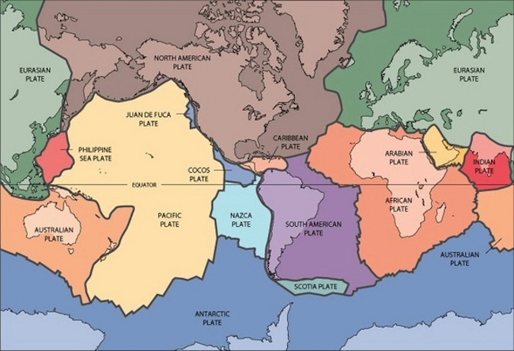
Tectonic plates of the Earth.
Credit: USGS
Continental drift was a theory that explained how continents shift position on Earth's surface. Set forth in 1912 by Alfred Wegener, a geophysicist and meteorologist, continental drift also explained why look-alike animal and plant fossils, and similar rock formations, are found on different continents.

The theory of continental drift
Wegener thought all the continents were once joined together in an "Urkontinent" before breaking up and drifting to their current positions. But geologists soundly denounced Wegener's theory of continental drift after he published the details in a 1915 book called "The Origin of Continents and Oceans." Part of the opposition was because Wegener didn't have a good model to explain how the continents moved apart.
Though most of Wegener's observations about fossils and rocks were correct, he was outlandishly wrong on a couple of key points. For instance, Wegener thought the continents might have plowed through the ocean crust like icebreakers smashing through ice.
"There's an irony that the key objection to continent drift was that there is no mechanism, and plate tectonics was accepted without a mechanism," to move the continents, said Henry Frankel, an emeritus professor at the University of Missouri-Kansas City.
Although Wegener's "continental drift" theory was discarded, it did introduce the idea of moving continents to geoscience. And decades later, scientists would confirm some of Wegener's ideas, such as the past existence of a supercontinent joining all the world's landmasses as one. Pangaea was a supercontinent that formed roughly 200 to 250 million years ago, according to the U.S. Geological Survey (USGS) and was responsible for the fossil and rock clues that led Wegener to his theory.
Plate tectonics is now the widely accepted theory that Earth's crust is fractured into rigid, moving plates. In the 1960s, scientists discovered the plate edges through magnetic surveys of the ocean floor and through the seismic listening networks built to monitor nuclear testing. Alternating patterns of magnetic anomalies on the ocean floor indicated seafloor spreading, where new plate material is born. Magnetic minerals aligned in ancient rocks on continents also showed that the continents have shifted relative to one another.
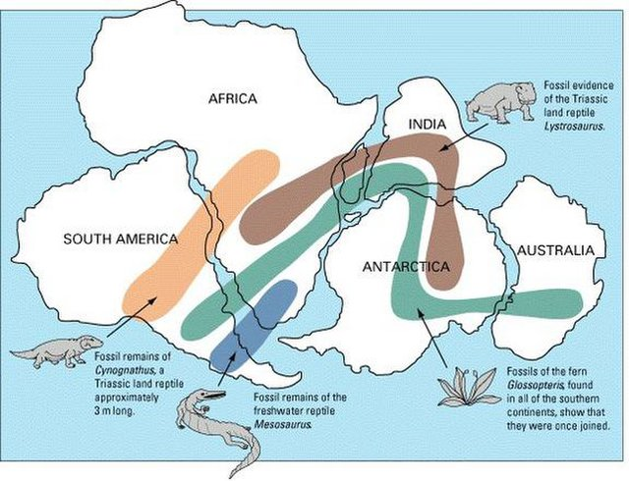

The theory of continental drift reconciled similar fossil plants and animals now found on widely separated continents. Gondwana is shown here.

Evidence for continental drift
A map of the continents inspired Wegener's quest to explain Earth's geologic history. Trained as a meteorologist, he was intrigued by the interlocking fit of Africa's and South America's shorelines. Wegener then assembled an impressive amount of evidence to show that Earth's continents were once connected in a single supercontinent.
Wegener knew that fossil plants and animals such as mesosaurs, a freshwater reptile found only South America and Africa during the Permian period, could be found on many continents. He also matched up rocks on either side of the Atlantic Ocean like puzzle pieces. For example, the Appalachian Mountains (United States) and Caledonian Mountains (Scotland) fit together, as do the Karroo strata in South Africa and Santa Catarina rocks in Brazil.
In fact, plates moving together created the highest mountains in the world, the Himalayans, and the mountains are still growing due to the plates pushing together, even now, , according to National Geographic.
Despite his incredible evidence for continental drift, Wegener never lived to see his theory gain wider acceptance. He died in 1930 at age 50 just two days after his birthday while on a scientific expedition in Greenland, according to the University of Berkley.

