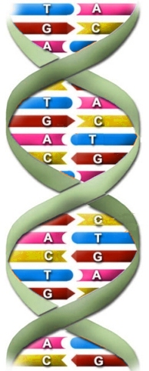
We study DNA for many reasons, including:
- Its central _________________ to all life on Earth
- It leads to _______________ benefits such as _____________ for ______________
- It helps us ___________ better food crops
Review: The Shape of the DNA Molecule
- DNA is a very long _____________ (poly = many)
- The basic shape is like a twisted _______________ or _____________.
- The name for this shape is a “______________ ___________”
DNA Model
- DNA is made of ___ different nitrogen ___________ that are but in a different order to make different genes:
A_____________ T_____________ G_____________ C_____________
Two Stranded DNA
- Remember, DNA has ___ strands that ______ ________________ something like a zipper.
Hydrogen Bonds
- The bases stick together because of ___________________ bonds. Hydrogen bonds are weak but there are millions and millions of them in a _____________ molecule of DNA.
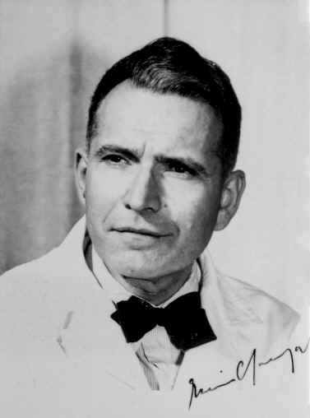
- When making hydrogen bonds:
  - _____________ ALWAYS pairs up with _____________
  - _____________ALWAYS pairs up with ______________
  - This is called “Chargraff’s ________”
DNA by the Numbers
- Each cell has about ____ meters of DNA
- The average human has _____ trillion cells
DNA Replication
- When the cell wants to _____________ it has to copy its insides first, including its ________.
- You’d first need to be able to read the DNA to copy it…
- So the cell “____________” the DNA into two separate ___________. Now you have ____ templates the cell can read and copy.
- The process of DNA replication turns 1 strand of ______ into ____.
- Each contains one ______ side of the original DNA and one side made of “______” bases
- Replicate the following DNA sequence, remembering that As go with Ts, and Cs with Gs:
AGG-CTC-AAG-TCC-TAG

