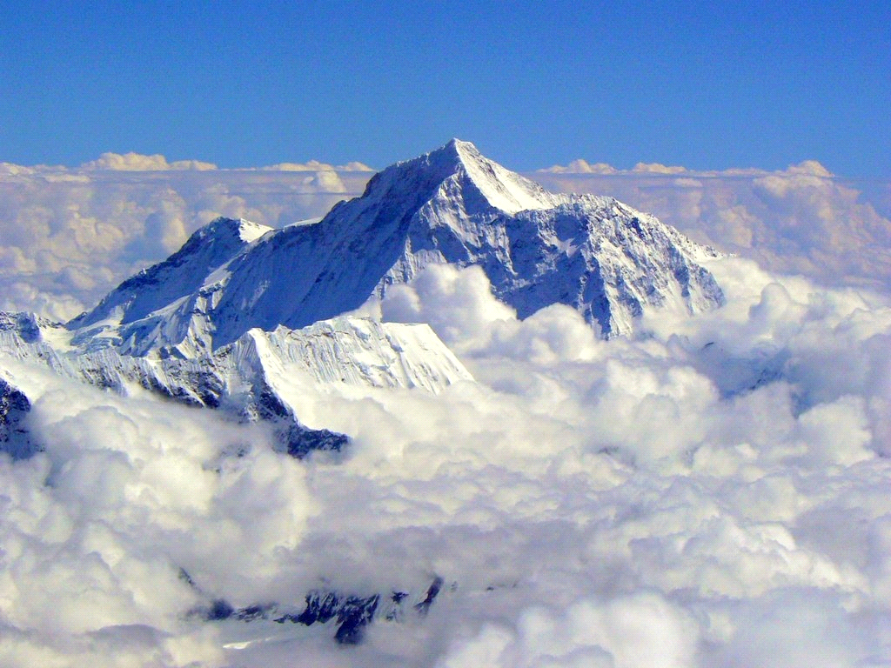
Famous Land and Water Features Project.

Mrs. Hilario
Earth Science

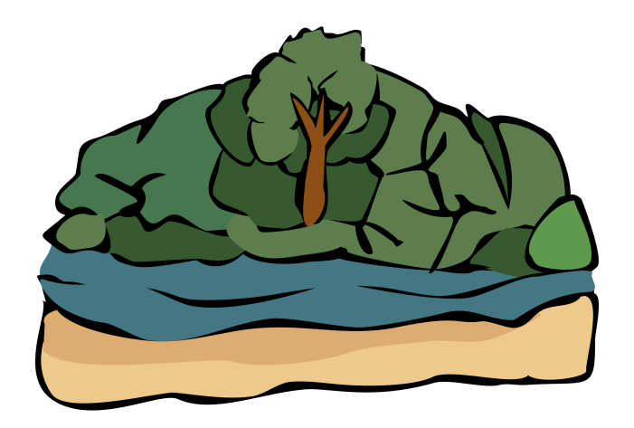
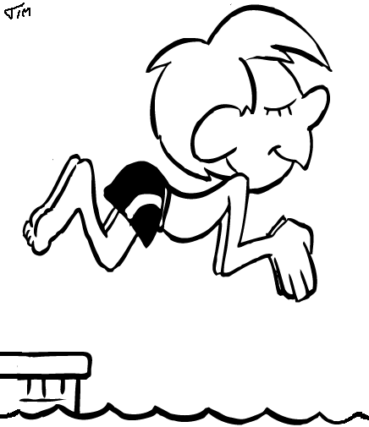
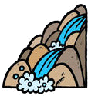

Famous Land and Water Feature Project

Name:

What is your famous land or water Feature?

For this project, you will be researching a famous land or water feature. Following your research, you will be writing an informative piece on your famous feature using the information from your research.

On March 29, 2018, you will present your project to the class.

There is specific information you must have included in your writing piece. They are listed below along with the amount of points each piece of information is worth. It is very important that you check your spelling and write in complete sentences.

Lastly, you will need to cite your sources. Any website or resource that you use, you must have listed with your project. This is to make sure that you are not plagiarizing which could result in a zero on the project.

You must write a rough draft and a final copy that should be typed on Google Docs and submitted to Mrs. Hilario. Please use your time wisely and have fun!

Writing Piece Presentation

Name of your feature
and how it received its name: /5 Loud and Clear: /5 Location of your feature: /5 Prepared: /5
The type of feature: /5 Poster: /15
- name of feature
Description of feature: /5 - drawing/print out
- colorful, creative, and neat

Interesting Facts: / 5 Grammar and Spelling: /5 Citing Your Sources: /5 Total Score: /35

Spelling: /5

Your Full Name: /5 Thorough Information: /5 Total Score: /45

List of Land and Water Features

Victoria Falls - Maggie

Andes Mountains - Rogelio

Great Lakes - Zachary
Grand Canyon - Cesar
Great Rift Valley - Gabriel
Mount Everest - Samantha
Himalayan Mountains - Annett
Mid-Atlantic Ridge -Manny
Mariana Trench - Cobe

Graphic Organizer
Name:

Feature:

How It Received Its Name
Location of Feature (state, country, or continent?)
Type of Feature (give details on why it is categorized as that feature)

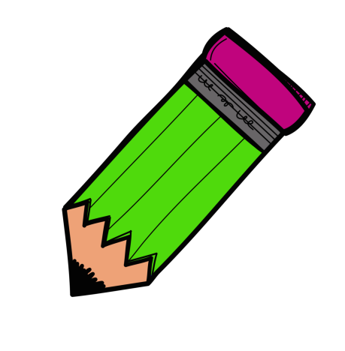

Description of Feature (what does it look like?)
_____________
___ _____

Interesting Facts
__________
1.

2.

3.

CITE YOUR SOURCES ☺☺

Checklist

- Graphic Organizer/Sources
- Rough Draft
- Edit With Someone
- Edit With A Teacher
- Final Copy (Google Docs)
- Poster
- Practice Speech With a Partner

