MITOSIS

- When ________________(body) cells reproduce themselves the process is called _________________.

- Main purposes of mitosis:
1. | 2. | 3. Asexual _______________ (bacteria)

- Mitosis leads to the production of two “__________________________________ cells.”
- Each daughter cell has the ______ ___________ ________________ as the ___________________ cell. All cells made by Mitosis are _____________________, containing 2 copies of each chromosome (____)

MEIOSIS
- When ___________(sperm or egg) cells reproduce themselves the process is called ___________. Meiosis reduces chromosome # in ________. Each cell made by Meiosis contains only 1 copy of each chromosome (n).
- During meiosis, a single ______________ cell divides and produces _____ genetically ___________ __________ cells.
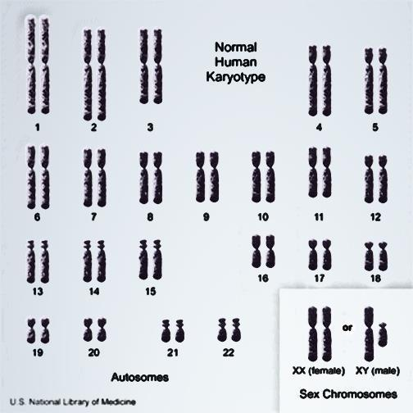
- In Meiosis __________ ______ occurs, where the chromosomes next to each other (______________ chromosomes) swap genes, this ___________ genetic variety in the potential offspring.

Mitosis or Meiosis? Fill in each blank using your notes:
1. Asexual Reproduction? _____________  2. Results in 2 identical cells? ____________  3. Results in 4 non-identical cells? ___________  4. Produces gametes? _____________  5. Results in variation? _____________ | 6. Results in haploid cells? _____________  7. Used for growth and repair? _________  8. Skin cells? _____________  9. Sperm cells? _____________  10. Makes 2n cells? ____________

Sex Chromosomes: A single ______________ of chromosomes that determines the gender of the organism. Always put ___________, as pair #______.
- Female = ____ ___ (_____ from mom, _____ from dad)
- Male =_____ _____ (_____ from mom, _____ from dad) *Only pair that does NOT match by _________!*
Autosomes: All other ______________ not involved in gender determination. Pairs #1-22, Put from __________to ___________ (followed by sex chromosomes). -Matched by same _____________, like socks!
1 N egg
1 N sperm
Upon fertilization, a “N” sperm meets a “N” egg and a zygote (2N) is formed.

2N zygote
+

- Crossing Over: Homologous ________________swap some genes during _______ only. This creates variety in the gametes!
  - This is why you don’t look exactly like any ___________, even though you have the ________ mom and dad.
Chromosomal Disorders
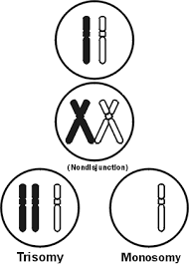
- Humans have ___ pairs of chromosomes, with one ________________from each parent. The chromosomes are coiled up ____. Under normal conditions all of the chromosomes are inherited intact and in _____.
- ___________: when cells go through meiosis, portions of the chromosome are lost.
- ___________: when cells go through meiosis, parts of the chromosome are flipped.
- ________________: when cells go through meiosis, parts of the chromosomes stick together and switch.
- ________-_____________: when cells go through meiosis the chromosomes don’t separate correctly and either too many or not enough are passed on.

PICK 2 of the CHROMOSOMAL DISORDERS, Take Notes below:
Disorder name:______________________________________  How rare? 1 in __________  What went wrong during meiosis? Which of the 4 types of chromosome mutations?  ________________________________________________________________________________________________________________________________________________  What are the symptoms? What genes are affected?  ________________________________________________________________________________________________________________________________________________ | Disorder name:______________________________________  How rare? 1 in __________  What went wrong during meiosis? Which of the 4 types of chromosome mutations?  ________________________________________________________________________________________________________________________________________________  What are the symptoms? What genes are affected?  ________________________________________________________________________________________________________________________________________________

