Name:____________________________ Date:_____________

The Big Bang Theory

Most astronomers believe the Universe began in a Big Bang about _____________________ years ago.
At that time, the entire Universe was inside a bubble that was thousands of times smaller than a _____________________. It was _____________________ and _____________________ than anything we can imagine.
Then that bubble suddenly _____________________ and the Universe that we know was born. _________________, ______________ and __________________ all began with the Big Bang. In a fraction of a second, the Universe grew from smaller than a _____________________to bigger than a _____________________. And it kept on growing at a fantastic rate. It is still _____________________ today.
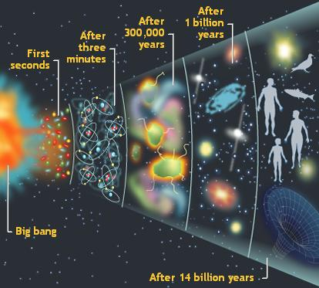
As the Universe _____________________ and ___________________, energy changed into _________________________ and ___________________. These two opposite types of particles _____________________ each other. But some matter survived. More stable particles called ______________ and _________________ started to form when the Universe was _____________________ old.

Over the next _____________________, the temperature dropped below _____________________ degrees Celsius or _________________________ (One trillion, 800 billion, and thirty two). It was now cool enough for the protons and neutrons to come together, forming _____________ and ______________ nuclei.

After _______________ years, the Universe had cooled to about ________ degrees. Atomic nuclei could finally capture _____________________ to form atoms. The Universe filled with _______________ of hydrogen and helium gas.

We cannot see anything that happened during the first _____________________ of the Universe. Scientists try to work it out from their knowledge of atomic particles and from computer models.

The only direct evidence of the Big Bang itself is a faint glow in space. Spacecraft and telescopes see this as a patchy pattern of slightly _________________ and _______________ gas all around us. These ripples also show where the hydrogen clouds were slightly denser.
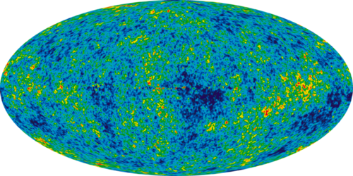

As millions of years passed, the ____________________ areas pulled in material because they had more ___________________. Finally, about _____________________ years after the Big Bang, the gas became hot and dense enough for the first _____________ to form.

New stars were being born at a rate _________________ higher than in the present-day Universe. Large _____________________ soon became the first _________________.

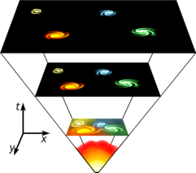
The Hubble Space Telescope and powerful ground-based telescopes are now beginning to find galaxies that were created about one billion years after the Big Bang. These small galaxies were much ______________ together than galaxies are today. _________________ were common.
Like two flames moving towards each other, they merged into _______________ galaxies. Our _________________ galaxy came together in this way.

Independent Practice
Q1. About how old is the Universe?

Q2. Explain using your own words what the Big Bang Theory is. Include the big highlights.

Q3. The Universe is not just made up of atoms. What else makes up the Universe?

Q4. Explain 2 ways that the Universe could end?

Q5. What have you found to be the most interesting from what you have learned about the Big Bang theory, so far? Explain why.

Q6. Circle which is larger:

The universe or a galaxy?

The universe or a star?

A galaxy or a star?

