Using the mRNA strands provided, use the codon chart provided to help you find the amino acid each codon code for.
1.
mRNA | AUG-GAU-UCG-CGA-UAA
Amino Acids | ____ -____ -____ -____ -____
2.
mRNA | AUG-CUA-AGG-GAC-UAG
Amino Acids | ____ -____ -____ -____ -____
3.
mRNA | AUG-GGG-CAG-UUU-UGA
Amino Acids | ____ -____ -____ -____ -____

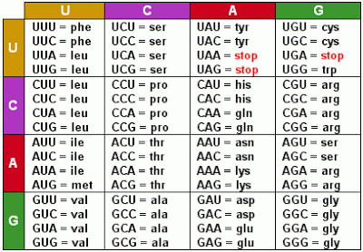
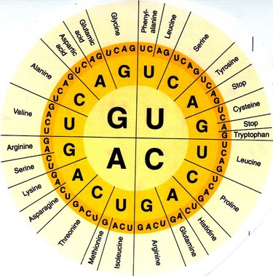

Using the mRNA strands provided, use the codon chart provided to help you find the amino acid each codon code for.
1.
mRNA | AUG-GAU-UCG-CGA-UAA
Amino Acids | ____ -____ -____ -____ -____
2.
mRNA | AUG-CUA-AGG-GAC-UAG
Amino Acids | ____ -____ -____ -____ -____
3.
mRNA | AUG-GGG-CAG-UUU-UGA
Amino Acids | ____ -____ -____ -____ -____

